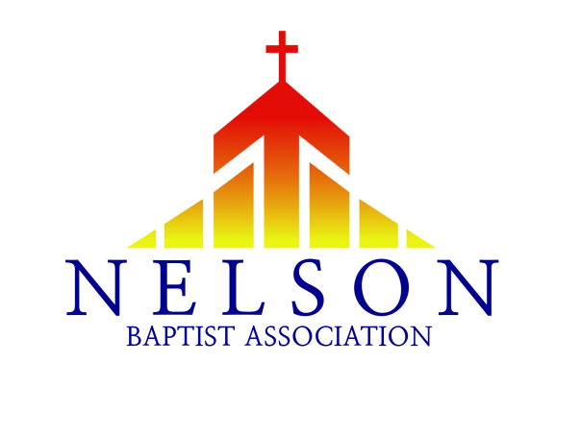
The purpose of this cover letter is to inform and guide the local churches of the Nelson Baptist Association in the proposed updates and changes to the Constitution and By-Laws of the association. These proposed changes will be presented and voted on at our Annual Meeting on Sunday, September 10th at Parkway Baptist Church in Bardstown.
Last year at the Annual Meeting, Recommendation 3 was withdrawn by the Administrative Team in order to have an opportunity for further dialog before it is presented at this year’s Annual Meeting. This recommendation regarded a local church’s cooperation with the Southern Baptist Convention and membership in the Nelson Baptist Association.
The following was proposed by Matthew Spandler-Davison, Pastor of Redeemer Fellowship Church in Bardstown and adopted by the Administrative Team:
I) Whereas we appreciate that the Nelson Baptist Association (in its original form) predates the Southern Baptist Convention and therefore was not originally founded as an association of Southern Baptist Churches.
II) Whereas we further appreciate that, since the establishment of the Kentucky Baptist Convention and the Southern Baptist Convention, the Nelson Baptist Association has been an association of Baptist churches which are in good standing and in friendly cooperation with the Southern Baptist Convention.
III) Whereas we acknowledge that the Baptist Faith and Message 2000 is not the only Baptist confession that Nelson Baptist Churches can adopt but it is the Statement of Faith of the NBA and therefore all churches in association with the NBA have been expected to affirm this statement.
IV) We further acknowledge that some churches currently in the Nelson Baptist Association are, for reasons of their own choosing as autonomous local churches, choosing to remove themselves from friendly cooperation with the Southern Baptist Convention.
V) We further acknowledge that there are like-minded baptistic churches in our region who are not presently affiliated with the Southern Baptist Convention, but which are willing to affirm the Baptist Faith and Message 200 and would be minded to seek to partner with the churches of the Nelson Baptist Association.
To that end, we recommend,

I) That the Nelson Baptist Association adopts the BFM 2000 as its Statement of Faith and all churches affiliated with the NBA are to likewise record an affirmation of the BFM 2000. However, it is not required that the BFM 2000 be formally adopted by that church as its own Statement of Faith when a similar baptistic statement of faith has been adopted by that church.
II) The term “full members” of the Nelson Baptist Association will refer to those churches which are in friendly cooperation with the Southern Baptist Convention.
- The term “Associate Members” of the Nelson Baptist Association will refer to those churches which are able to affirm the BFM 2000 but are not in friendly cooperation with the Southern Baptist Convention. Members of an Associate Member Church will be invited to attend NBA Annual Meetings and other business meetings but will not be able to nominate messengers with voting rights.
- Members of an Associate Member Church can attend and participate in ministry teams but cannot serve as an officer of the association.
- Associate Member Churches are required to be a financial contributor to the Nelson Baptist Association and can apply for support, services, and grant funds from the NBA Ministry Teams.
You will find these changes implemented into the body of our Constitution and By-Laws. The primary changes can be found under ARTICLE IV: MEMBERSHIP AND PRIVILEGES. The rest of the changes is just changing the language of each section to reflect the changes made under ARTICLE IV.
As always, if you have any questions, you may contact us at the association office by phone 502-348-0146 or email nelsonbaptistassociation@gmail.com. We will also be hosting several discussion times around our association to answer any questions regarding the proposed changes. Be on the look out for these dates in the coming weeks.

